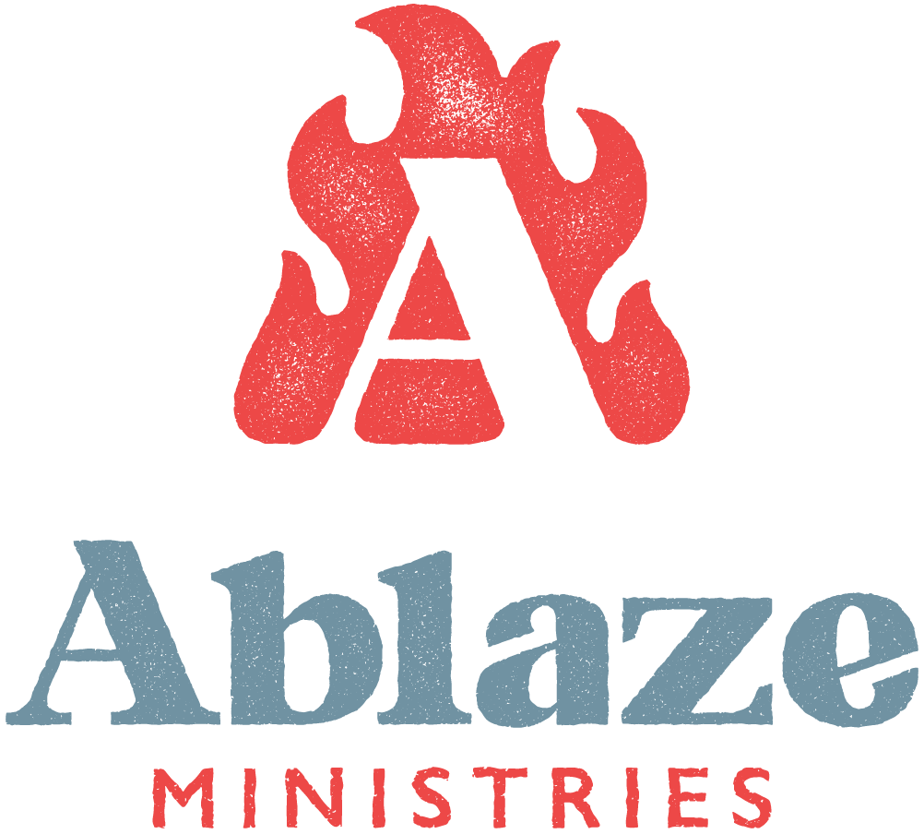

Updated: February 20, 2020

MISSION OF ORGANIZATION
The mission of Ablaze Ministries is to implement the US Bishops’ vision of comprehensive youth ministry by engaging, nurturing, and empowering discipleship in young people, ministers and volunteers, as well as within families.

For the youth: Ablaze Ministries enables schools and parishes of all sizes to sustain professional, cost-effective, and enthusiastic ministry rooted in prayer, fellowship, and formation. Our ministry enables collaboration of community parishes, highlighting the true connectedness of the universal Church.

For the ministers: Ablaze Ministries provides youth ministers with spiritual formation, professional development, and theological training. Our team of missionaries work together in community, sharing each other’s gifts and holding each other accountable to meet the needs and the call of the Catholic Church.

CURRENT POSITION INFORMATION

Job Title: Intern for Summer 2020

Supervisor: Youth Minister,  Director of Youth Ministry | Position Type: Full-Time
Location: Bryan, TX; Waco, TX; St. Louis,  MO | Salary: Fundraised
Start Date: May 26th | End Date: August 5th
Applications Due: March 23rd

DESCRIPTION
Ablaze Ministries is a non-profit organization working within Catholic parishes to provide effective youth ministry. The Intern serves as a part-time or full-time missionary for the entirety of the internship length specified. Ablaze Ministries provides time for fundraising before Interns enter their assigned parish ministry and training during the internship. Ablaze Ministries also provides 1-on-1 mentorship for everyone on staff, including Interns.
Our team is looking for someone who loves their Catholic faith, is passionate about youth ministry and the New Evangelization, and is willing to start each workday in prayer with the staff. The candidate must have excellent motivational leadership skills, be well organized, have superb verbal and written communication skills, and the ability to collaborate with teams of adult volunteers. The candidate must exemplify our core values of high integrity, team oriented, committed to excellence, joy, humble service & passionate about youth.

MAJOR DUTIES AND RESPONSIBILITIES
Each Intern at Ablaze Ministries is expected to have a life of prayer and a continued effort to unite one’s heart to Christ.
Responsibilities of the Intern will also include:

- Serving in youth summer events, monthly activities, and camps at the assigned parish for both middle school (7th – 8th grade) and high school (9th – 12th grade) programs
- Participation in partner Youth Ministers’ weekly youth nights
- Attend weekly Youth Minister meetings and occasional parish staff meetings
- Contribute to Ablaze Ministries’ online resources
- Lead and run a specialized, parish-wide project
- Provide support for larger events hosted by the parish and Ablaze Ministries

EXPECTATIONS AND REQUIREMENTS TO APPLY

- Interns must have completed their freshman year of college
- Should be interested in youth ministry
- Must be able to reside in the location of the parish throughout the entirety of the internship program
- Interns will fundraise their salary for the semester. (For questions contact Debra at debra@ablaze.us).
- Should be a practicing Catholic seeking to grow in their faith.

HOUSING AND TRANSPORTATION
- Cost of travel to and from internship location at the beginning and end of the internship is the Intern’s responsibility
- Ablaze will help with transportation during the internship if needed.
- Housing will not be provided for the internship. However, Ablaze is willing to help interns find housing.

ORGANIZATION STRUCTURE
Supervisor/Manager: Youth Minister and Director of Youth Ministry
Peers: Interns

HOW TO APPLY

Please apply through our website at ablaze.us/intern. In the application, make sure to submit a resume, three references (one being a priest to confirm you are a Catholic in good standing), and a 3-5 minute testimony video.

